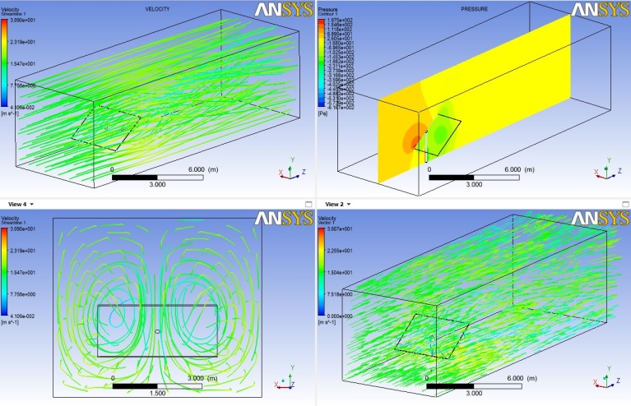
Analyze and visualize the wind loading on the solar trackers using the computational fluid dynamics

CFD for Solar Trackers
Ezhilmathi Krishnasamy
Wind loading is one of the major external loads which cause more damage to the solar tracers. CFD is used to investigate and visualize the how wind load acts on the solar trackers. Different cases have been considered for the simulation results were discussed with real case scenario

C
ompressible flow analysis (computational fluid dynamics) was carried out around the solar trackers to analyze how the wind force is acting in the solar trackers. Two cases were considered for the simulation; one is open domain simulation and another one is similar to wind tunnel model. Structured and unstructured model is compared with each other. SST (shear stress transportation) solver is considered for the open domain simulation and DES (detach eddy simulation) were also considered for wind tunnel model simulation. Results were compared to each other as well as with wind tunnel data for the validation of the simulation. (Shear stress transportation) solver is considered for the open domain simulation and DES (detach eddy simulation) were also considered for wind tunnel model simulation. Results were compared to each other as well as with wind tunnel data.

Introduction

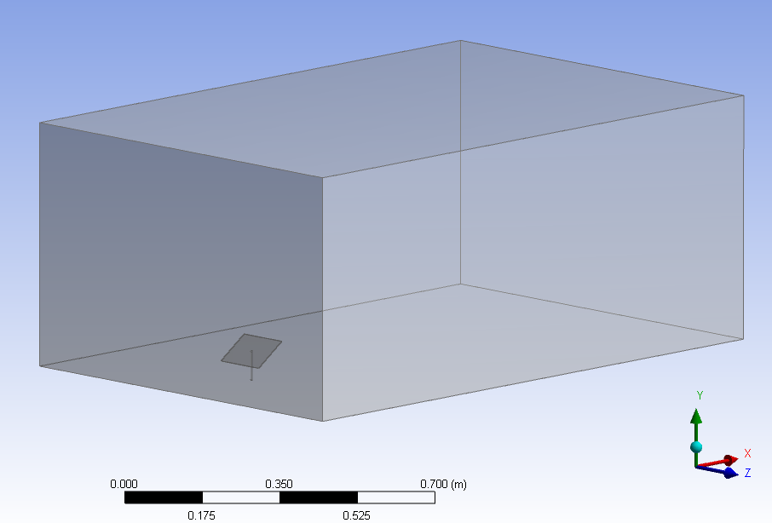
Solar energy is one of the renewable resource and solar trackers are the one who can convert solar energy into electrical energy. But some time due to external environmental weather causes more damage to the solar trackers. Even though we are getting energy from the renewable resource it has to be in an efficient way rather than installing often the solar trackers.
Standard model of the solar trackers that are in use were considered for the CFD simulation. But size is reduced to 1:33 for simulation and also for the wind tunnel experiment.
Figure 1: Domain model
Two kinds of simulation were carried out; one is the real case with reduced model of an open domain and another one model is to compare the wind tunnel data.

Methods

Geometry: geometry is created using the Ansys workbench design modeler. Figure 1 shows the solar panel width is 0.12 meter, breath is 0.09 meter and height is 0.112 meter if the panel is vertical (parallel to the support beam). For the real case motivation array of panels were also modeled with same dimension but 0.045 meter distance with each other. Open domain dimension is based on the well posedness boundary condition.
Mesh: Structured mesh is generated using the ICEM CFD that can be seen in the Figure 2 and unstructured mesh is created using Ansys default workbench meshing. Approximately 15 million hexahedron elements were created. Mesh is refined more closely to the walls to keep the y+ in recommended range because of the friction in the wall and boundary layer separation of the flow. For the unstructured mesh, the mesh quality is tested and kept in a desired range.
Orthogonal and skewness were in good range for the unstructured mesh. Boundary condition: In real case the wind velocity is 15 m/s but the velocity is recalculated according to the solar panel model using the similitude concept. Bottom wall and solar panel are set as no-slip wall and other three walls are set as free slip walls. Outlet is defined as zero pressure gradients.
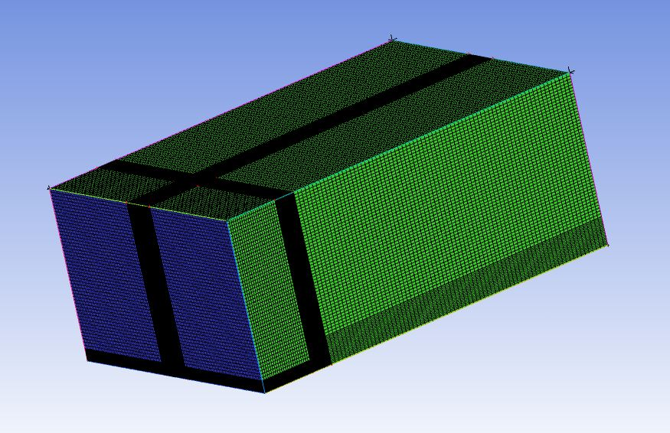
Solver setup: SST (shear stress Transportation) is chosen for the open domain problem and it based on the RANS model. Different angles and different wind velocity were used for the simulation to understand how the wind load (force) applied on the solar panel. K-omega is used in the SST solver.

Results

As we can see in the Figure 4 the pressure is acting more on the bottom half of the solar panel than the other parts. It is mainly due to panel is opposing the wind force. Whereas in other angles it is quite different how the force is acting on the panels.
But in the case of array of panels the first panel feeling more force than the second panel and the same time due to turbulence in the flow the second panel facing more wind force in the center of the panel. When it is come to different direction of the wind velocity the entire force acting on the panel looks different; it is mainly due to the wind direction of the wind. More or less the wind tunnel data and simulation data are closer to each other. So the approach and boundary condition that we have implemented was good.
Figure 2: Structured mesh with hexahedron elements

“We hope these results will be considered as detail information for the further analysis for the finite element analysis on the solar panel thus will lead to a better design in solar panel using proper material selection.”

Discussion
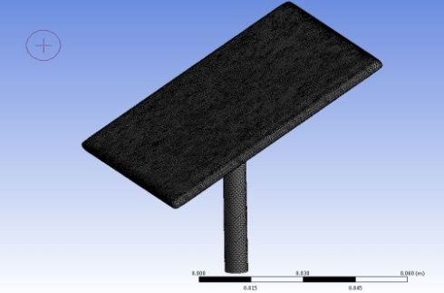
Several models were tried until to get a mesh independent. Some time it is trivial for fixing the boundary condition especially for the transient analysis. Depends on the mesh quantity the total time of the simulation varies. For example, if the mesh size is small results can be quicker with proper boundary condition. Since Ansys CFX uses the multigrid technique we get the results even quicker. Governing equations of the fluid flow problems should be discretized (for example, finite volume, finite element and finite difference) in order to get a good solution (approximation). Discretization has as results system of linear algebraic equations which depend on the problem domain and complexity of the problem. Any standard procedure could be used to solve this system of linear algebraic equations with help of the availability of the computer power but we are always interested in fast and accurate solution with reasonable computer resource. There are two standard methods available to solve the system of linear algebraic equations [1]. These methods are: Direct methods (for example, LU decomposition, Cholesky factorization and Gaussian elimination methods) Indirect or iterative methods (for example, Newton’s method, Bisection, Jacobi and Gauss-Seidel methods) generally, in the case of the direct methods, finite numbers of steps are required to solve the system of linear algebraic equations. For example, if the equation is order of 3 and with 3 unknowns then the 3³ number of the operation is needed in order to calculate the solution and also 3³ core memory is required to store co-efficient of the equations. [1] All the iteration methods start with the initial guess and consecutively progress until it reaches to the original solution. In the case of the iterative methods the number of steps is unpredictable and also the solution of the method depends on the uniqueness and existence of the equations (for example, diagonally dominant, symmetric and positive definite matrix). But the iterative methods are a good option for the spare matrix (most of the entries will be zero in the matrix) where non-zero elements can be stored in the core memory. Moreover, the iteration can be terminated at any time according to the residual error r = b – Ax even though the number of the iterations is unpredictable. [1]. Even though iterative methods require less memory it should be quicker to get a solution. A Jacobi and Gauss-Seidel methods convergence rate is depend on the size of the matrix for example, if the equation increases (finer mesh) the iteration will also increase. Jacobi method is still slower than the Gauss-Seidel because Jacobi does not use the new values that it has computed. This new computed val- ues will be used. Whereas in Gauss-Seidel the new computed values are updated consecutively for the present cycle of calculation. Multigrid Technique is a procedure or technique that helps the stationary iterative method to enhance their convergence rate. Many types of cyclic schemes are available for the multigrid technique but Figure 1. Shows the three standard procedure of multigrid cycles. In Figure 1 the iterations in V-cycle starts with the initial guess in finer mesh later it travels to coarser mesh before it reaches the finer mesh. Computational cost is less for the iterations in the coarser level. W-cycle in Figure 1 goes like zigzag before it reaches the finer mesh. The full multigrid method in Figure 1 shows that the initial iteration starts with coarser level mesh and continues as a V-cycle[1].
Figure 3: unstructured mesh with inflated boundary layer for better y-plus
Figure 4 from left iso-surface of the pressure at 0 Pa, velocity contour in vertical position at the center of the panel and velocity contour in horizontal at the middle of the panel

Conclusion
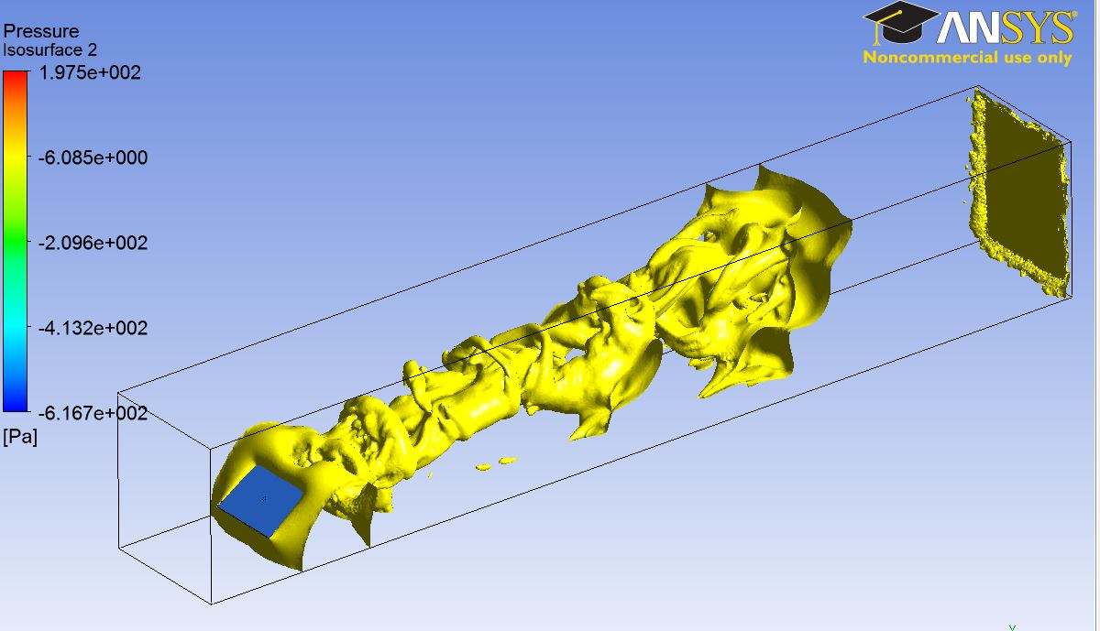
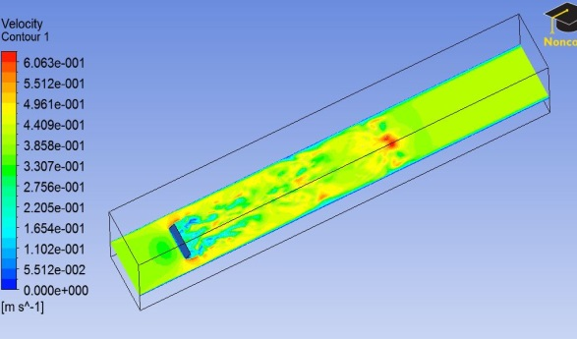
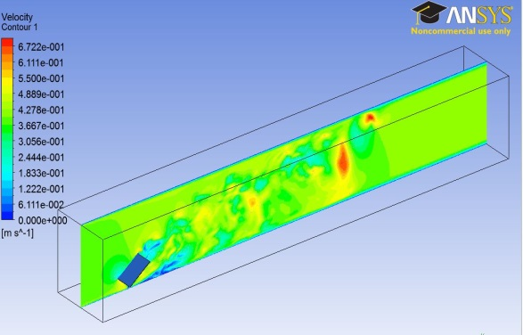
LES (Large eddy simulation) model values are closer to the wind tunnel model. In open domain simulation the results are also similar to the LES model. Depends on the mesh quantity the total time of the simulation varies. For example, if the mesh size is small results can be quicker with proper boundary condition. Since Ansys CFX uses the multigrid technique we get the results even quicker. Governing equations of the fluid flow problems should be discretized (for example, finite volume, finite element and finite difference) in order to get a good solution (approximation). Discretization has as results system of linear algebraic equations which depend on the problem domain and complexity of the problem. Any standard procedure could be used to solve this system of linear algebraic equations with help of the availability of the computer power but we are always interested in fast and accurate solution with reasonable computer resource. There are two standard methods available to solve the system of linear algebraic equations these methods are: Direct order to get a good solution (approximation). Discretization has as results system of linear algebraic equations which depend on the problem domain and complexity of the problem. Any standard procedure could be used to solve this system of linear algebraic equations with help of the availability of the computer power but we are always interested in fast and accurate solution with reasonable computer resource. There are two standard methods available to solve the system of linear algebraic equations. These methods are: Direct. Computer resource. There are two standard methods available to solve the system of linear algebraic equations. Solve the system of reasonable computer resource. There are two standard methods available to solve the system of linear algebraic equations. These methods are: Direct Computer resource. There are two standard methods available to solve the system of linear algebraic equations.[2]
PRACE SoHPCTitle
Wind loading on the solar tracker
PRACE SoHPCSite
University of Ljubljana,Slovenia
PRACE SoHPCAuthors
Ezhilmathi Krishnasamy
PRACE SoHPCMentor
Boris Jerman
PRACE SoHPCSoftware Applied
Ansys CFX
PRACE SoHPCMore Information
www.hpc.fs.uni-lj.si
PRACE SoHPCReferences
[1] H. Versteeg / W.Malalasekera (2007). An Introduction to Computational Fluid Dynamics: The Finite Volume Method, Prentice Hall.
[2] Micheal T. Heath (2005). Scientific Computing:An Introductory Survey, Second Edition, McGraw-Hill Education

